**SECTION 2**

**DP 2.1:**

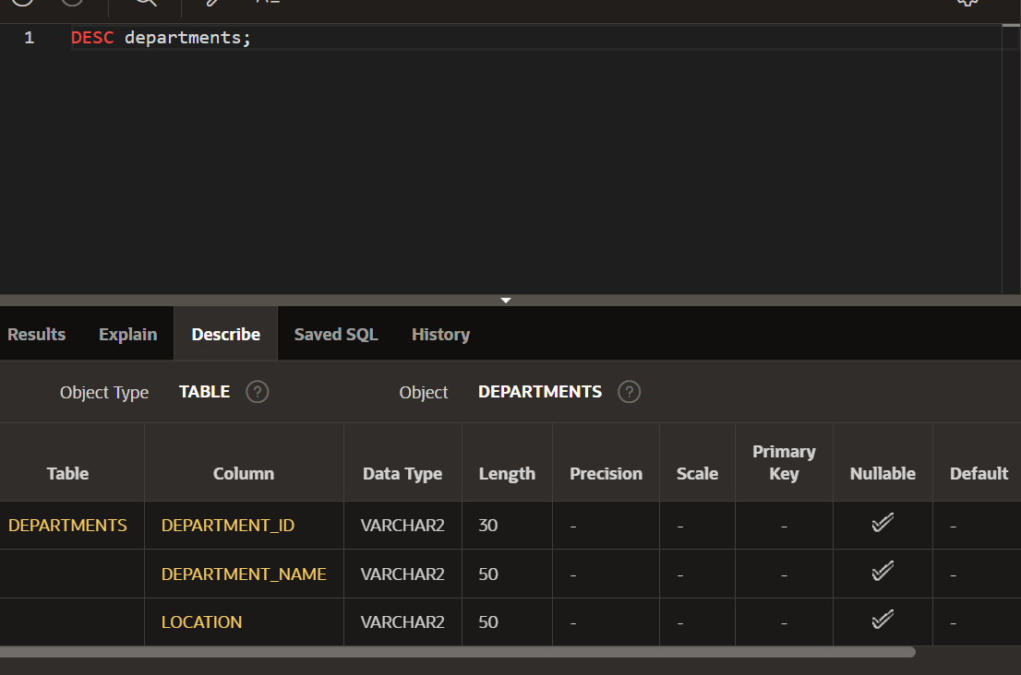

**DP 2.2:**

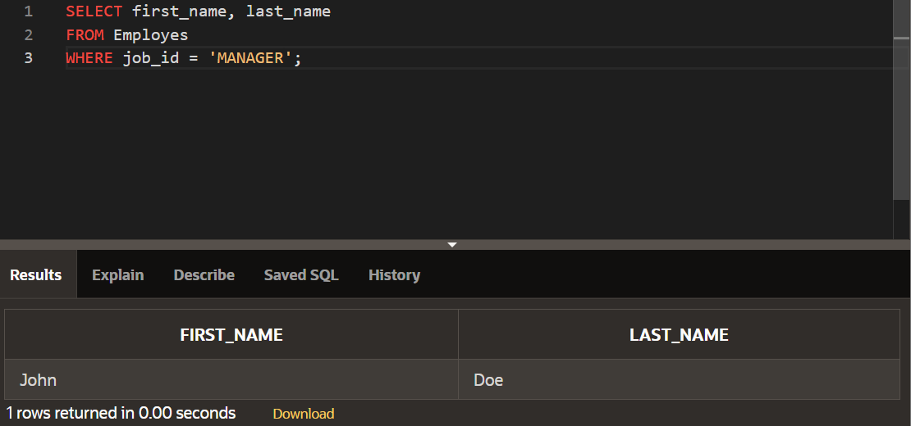

**DP 2.3:**



